**EXERCISE 10 – SIMPLE ANDROID APPLICATION THAT MAKES USE OF DATABASE**

##### Aim:

To develop a Simple Android Application that makes use of Database.

##### Procedure:

**Creating a New project:**

* Open Android Studio and then click on **File -> New -> New project.**

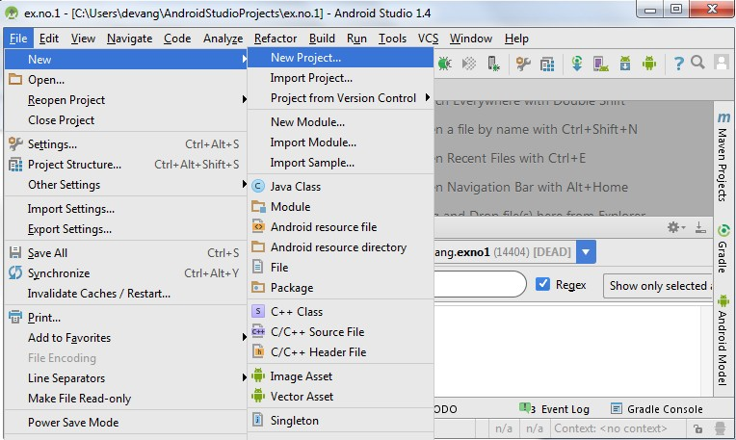

* Then type the Application name as “**ex.no.5″** and click **Next.**

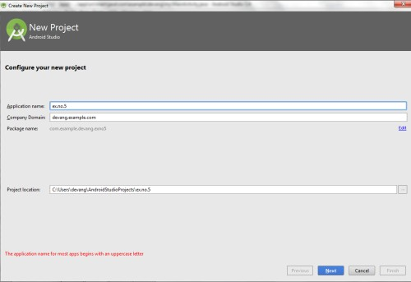

* Then select the **Minimum SDK** as shown below and click **Next**.

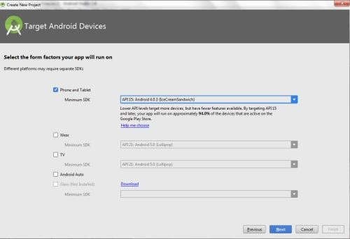

* Then select the **Empty Activity** and click **Next.**

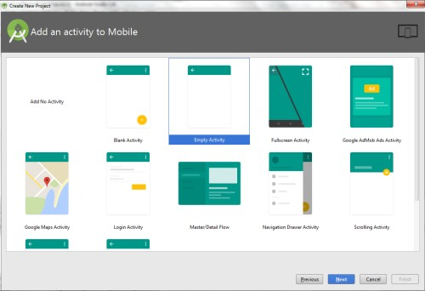

* Finally click F**inish**.

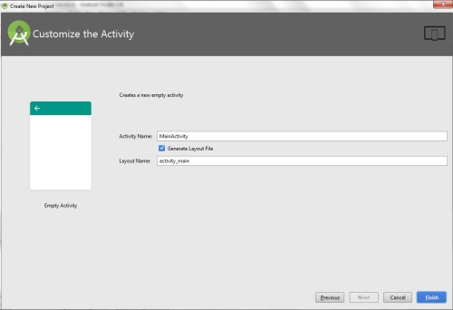

* It will take some time to build and load the project.
* After completion it will look as given below.

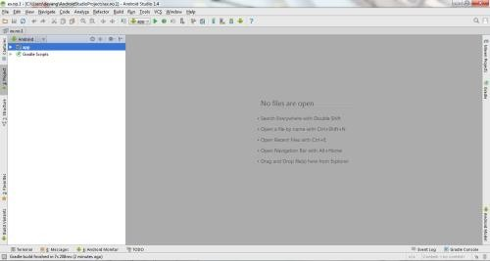

**Designing layout for the Android Application:**

* Click on **app -> res -> layout -> activity_main.xml.**

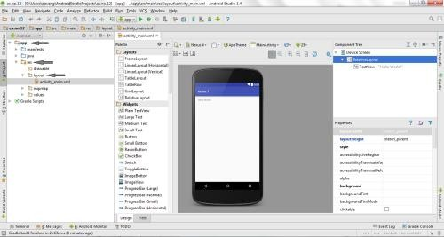

* Now click on **Text** as shown below.

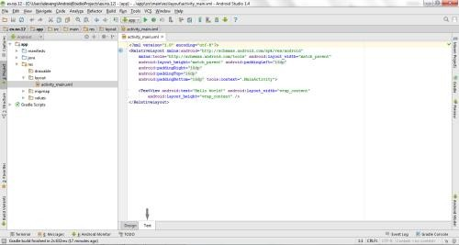

* Then delete the code which is there and type the code as given below.

##### Code for Activity_main.xml:

<?xml version="1.0" encoding="utf-8"?>

<AbsoluteLayout [xmlns:android="http://schemas.android.com/apk/res/android"](http://schemas.android.com/apk/res/android) android:layout_width="match_parent" android:layout_height="match_parent">

<TextView

android:layout_width="wrap_content" android:layout_height="wrap_content" android:layout_x="50dp" android:layout_y="20dp" android:text="Student Details" android:textSize="30sp" />

<TextView

android:layout_width="wrap_content" android:layout_height="wrap_content" android:layout_x="20dp" android:layout_y="110dp" android:text="Enter Rollno:" android:textSize="20sp" />

<EditText

android:id="@+id/Rollno" android:layout_width="150dp" android:layout_height="wrap_content" android:layout_x="175dp" android:layout_y="100dp" android:inputType="number" android:textSize="20sp" />

<TextView

android:layout_width="wrap_content" android:layout_height="wrap_content" android:layout_x="20dp" android:layout_y="160dp" android:text="Enter Name:" android:textSize="20sp" />

<EditText

android:id="@+id/Name" android:layout_width="150dp" android:layout_height="wrap_content" android:layout_x="175dp" android:layout_y="150dp" android:inputType="text" android:textSize="20sp" />

<TextView

android:layout_width="wrap_content" android:layout_height="wrap_content" android:layout_x="20dp" android:layout_y="210dp" android:text="Enter Marks:" android:textSize="20sp" />

<EditText

android:id="@+id/Marks" android:layout_width="150dp" android:layout_height="wrap_content" android:layout_x="175dp" android:layout_y="200dp" android:inputType="number" android:textSize="20sp" />

<Button

android:id="@+id/Insert" android:layout_width="150dp" android:layout_height="wrap_content" android:layout_x="25dp" android:layout_y="300dp" android:text="Insert" android:textSize="30dp" />

<Button

android:id="@+id/Delete" android:layout_width="150dp" android:layout_height="wrap_content" android:layout_x="200dp" android:layout_y="300dp" android:text="Delete" android:textSize="30dp" />

<Button

android:id="@+id/Update" android:layout_width="150dp" android:layout_height="wrap_content" android:layout_x="25dp" android:layout_y="400dp" android:text="Update" android:textSize="30dp" />

<Button

android:id="@+id/View" android:layout_width="150dp" android:layout_height="wrap_content" android:layout_x="200dp"

android:layout_y="400dp" android:text="View" android:textSize="30dp" />

<Button

android:id="@+id/ViewAll" android:layout_width="200dp" android:layout_height="wrap_content" android:layout_x="100dp" android:layout_y="500dp" android:text="View All" android:textSize="30dp" />

</AbsoluteLayout>

* Now click on **Design** and your application will look as given below.

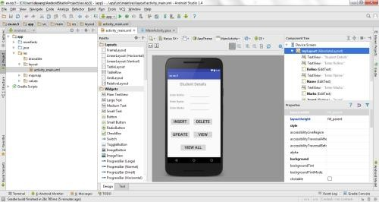

* So now the designing part is completed.

**Java Coding for the Android Application:**

* Click on **app -> java -> com.example.exno5 -> MainActivity.**

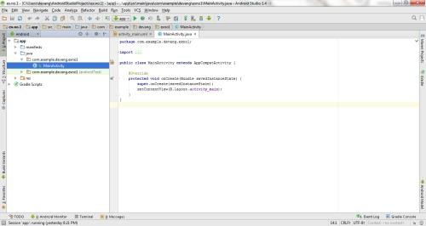

* Then delete the code which is there and type the code as given below.

##### Code for MainActivity.java:

package com.example.exno5; import android.app.Activity;

import android.app.AlertDialog.Builder; import android.content.Context;

import android.database.Cursor;

import android.database.sqlite.SQLiteDatabase; import android.os.Bundle;

import android.view.View;

import android.view.View.OnClickListener; import android.widget.Button;

import android.widget.EditText;

public class MainActivity extends Activity implements OnClickListener

{

EditText Rollno,Name,Marks;

Button Insert,Delete,Update,View,ViewAll; SQLiteDatabase db;

/** Called when the activity is first created. */ @Override

public void onCreate(Bundle savedInstanceState)

{

super.onCreate(savedInstanceState); setContentView(R.layout.activity_main);

Rollno=(EditText)findViewById(R.id.Rollno); Name=(EditText)findViewById(R.id.Name); Marks=(EditText)findViewById(R.id.Marks); Insert=(Button)findViewById(R.id.Insert); Delete=(Button)findViewById(R.id.Delete); Update=(Button)findViewById(R.id.Update); View=(Button)findViewById(R.id.View); ViewAll=(Button)findViewById(R.id.ViewAll);

Insert.setOnClickListener(this); Delete.setOnClickListener(this);

Update.setOnClickListener(this); View.setOnClickListener(this); ViewAll.setOnClickListener(this);

// Creating database and table db=openOrCreateDatabase("StudentDB", Context.MODE_PRIVATE, null); db.execSQL("CREATE TABLE IF NOT EXISTS student(rollno VARCHAR,name

VARCHAR,marks VARCHAR);");

}

public void onClick(View view)

{

// Inserting a record to the Student table if(view==Insert)

{

// Checking for empty fields if(Rollno.getText().toString().trim().length()==0||

Name.getText().toString().trim().length()==0|| Marks.getText().toString().trim().length()==0)

{

showMessage("Error", "Please enter all values"); return;

}

db.execSQL("INSERT INTO student VALUES('"+Rollno.getText()+"','"+Name.getText()+

"','"+Marks.getText()+"');"); showMessage("Success", "Record added"); clearText();

}

// Deleting a record from the Student table if(view==Delete)

{

// Checking for empty roll number if(Rollno.getText().toString().trim().length()==0)

{

showMessage("Error", "Please enter Rollno"); return;

}

Cursor c=db.rawQuery("SELECT * FROM student WHERE rollno='"+Rollno.getText()+"'", null);

if(c.moveToFirst())

{

db.execSQL("DELETE FROM student WHERE rollno='"+Rollno.getText()+"'");

showMessage("Success", "Record Deleted");

}

else

{

}

showMessage("Error", "Invalid Rollno");

clearText();

}

// Updating a record in the Student table if(view==Update)

{

// Checking for empty roll number if(Rollno.getText().toString().trim().length()==0)

{

showMessage("Error", "Please enter Rollno"); return;

}

Cursor c=db.rawQuery("SELECT * FROM student WHERE rollno='"+Rollno.getText()+"'", null);

if(c.moveToFirst()) {

db.execSQL("UPDATE student SET name='" + Name.getText() + "',marks='" + Marks.getText() +

"' WHERE rollno='"+Rollno.getText()+"'"); showMessage("Success", "Record Modified");

}

else {

showMessage("Error", "Invalid Rollno");

}

clearText();

}

// Display a record from the Student table if(view==View)

{

// Checking for empty roll number if(Rollno.getText().toString().trim().length()==0)

{

showMessage("Error", "Please enter Rollno"); return;

}

Cursor c=db.rawQuery("SELECT * FROM student WHERE rollno='"+Rollno.getText()+"'", null);

if(c.moveToFirst())

{

}

else

{

}

}

Name.setText(c.getString(1)); Marks.setText(c.getString(2));

showMessage("Error", "Invalid Rollno"); clearText();

// Displaying all the records if(view==ViewAll)

{

Cursor c=db.rawQuery("SELECT * FROM student", null); if(c.getCount()==0)

{

showMessage("Error", "No records found"); return;

}

StringBuffer buffer=new StringBuffer(); while(c.moveToNext())

{

buffer.append("Rollno: "+c.getString(0)+"\n"); buffer.append("Name: "+c.getString(1)+"\n"); buffer.append("Marks: "+c.getString(2)+"\n\n");

}

showMessage("Student Details", buffer.toString());

}

}

public void showMessage(String title,String message)

{

Builder builder=new Builder(this); builder.setCancelable(true); builder.setTitle(title); builder.setMessage(message); builder.show();

}

public void clearText()

{

Rollno.setText("");

Name.setText("");

Marks.setText(""); Rollno.requestFocus();

}

}

* So now the Coding part is also completed.
* Now run the application to see the output.

##### Output:

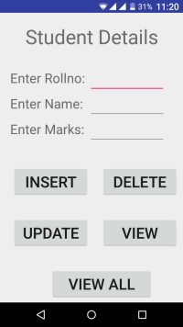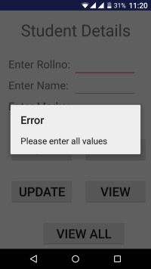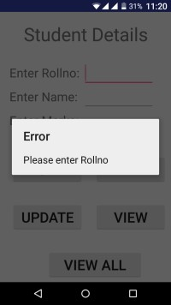

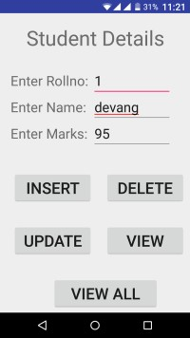 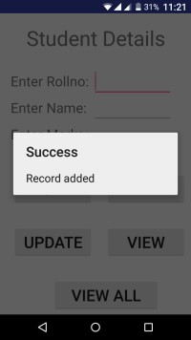 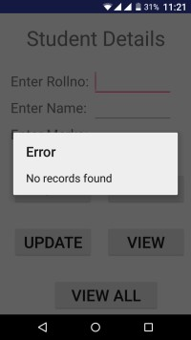

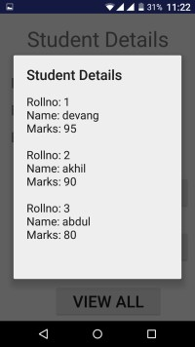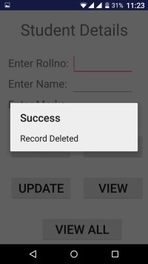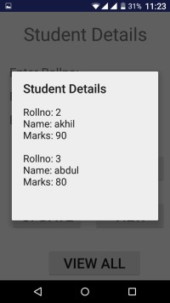

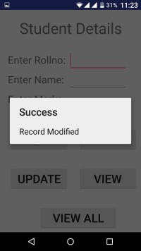 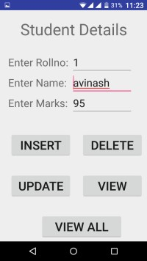

##### Result:

Thus a Simple Android Application that makes use of Database is developed and executed successfully.

##### EXERCISE 5.1:

Execute the above exercise of database in Android studio and show the exact GUI output? [10]

##### TASK 5.1

#### Develop an android application to display all the data of students in a LISTVIEW widget by using Android Sqlite tutorial.

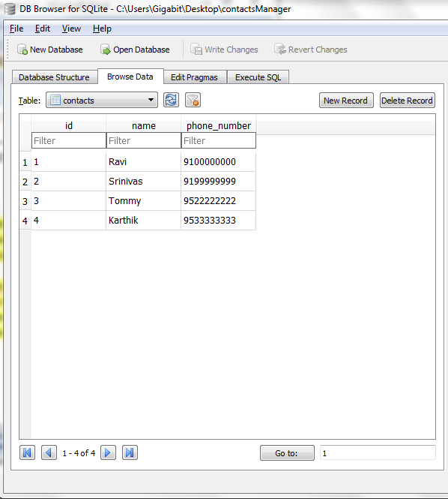

##### RESOURCES:

<https://www.codingconnect.net/mobile-application-development-lab/> <https://www.javatpoint.com/android-tutorial> <https://www.tutorialspoint.com/android> <https://developer.android.com/guide> [Https://developer.Android.com/training/basics/firstapp/creating-project](https://developer.android.com/training/basics/firstapp/creating-project)

[Https://www.raywenderlich.com/120177/beginning-Android-development-tutorial-](https://www.raywenderlich.com/120177/beginning-Android-development-tutorial-installingAndroid-studio) [installingAndroid-studio](https://www.raywenderlich.com/120177/beginning-Android-development-tutorial-installingAndroid-studio) <https://www.youtube.com/playlist?list=PLS1QulWo1RIbb1cYyzZpLFCKvdYV_yJ-E> [Https://www.udemy.com/java-tutorial/](https://www.udemy.com/java-tutorial/)

[Https://www.w3schools.com/xml/](https://www.w3schools.com/xml/) [Http://www.Androidguys.com/](http://www.androidguys.com/)